**SUICIDE TRENDS Age vs Generation**

In this section, we reviewed the suicide trends experienced by Age vs Generation. We determined the break down of the total number of suicides reported by age and generation.

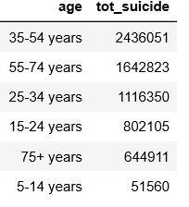 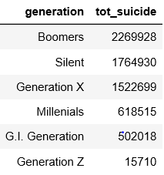

After pulling the total sum of suicides reported by age and generation, we investigated the data further to provide more detail for our analysis.

The first goal was to determine how many of the total suicides represent females vs. males for each category.

**Suicide rates comparison for different age groups – Male vs Female**

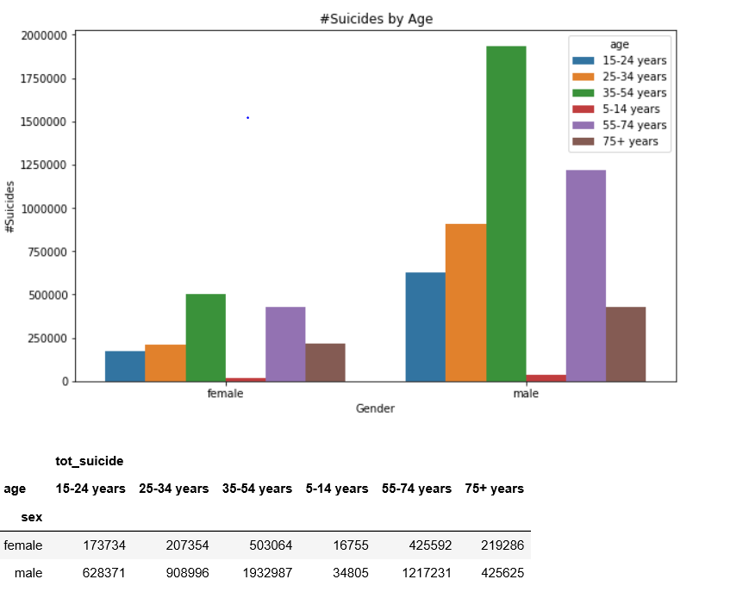

**Figure 1 Total Suicides for Females and Males by Age**

Figure 1 reflects the total number of suicides comparing female vs male by age. As shown in the figure, male suicide rates appear to be higher across all age groups when comparing against females in the same age grouping. The figure reflects suicide rates that are the highest are male and are in the age group35-54 years with the second highest being males in the age group 55-74.

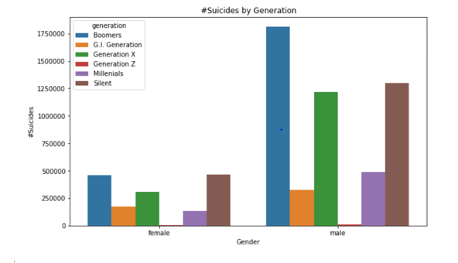

**Figure 2 Figure 1 Total Suicides for Females and Males by Generation**

Similarly, to Figure 1, Figure 2 shows that males suicide rates are the highest when comparing them to their female counterparts in the same generation. The figure further reflects the highest number of suicides amongst males are those from the Boomer generation closely followed by those in the Silent generation than Generation X.

Figure 3 reflects the difference between males and females in each generation is greatly differs apart from Generation Z, which has the least number suicides with the difference of 3,600 suicides between the two sexes. Statistics Canada analysis confirms that male suicide rates tend to be 3 times higher than female rates.

Fig 3. 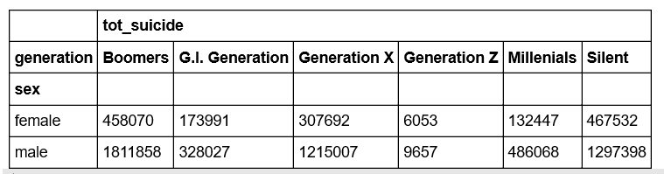

**3. Yearly suicide trends –**

After looking at the trends for different age groups, this section will summarize the overall trends combined for all age groups to see how suicide number change over the years by female vs male.

Using

generation_summary1=master_good.groupby(['country','sex','generation','year']).agg(tot_suicide=('suicides_no','sum')).unstack()

generation_summary1

We grouped the information from the data set to pull all countries, generation year and to break it down by sex. The output from the code is reflected in figure 4.

Fig 4.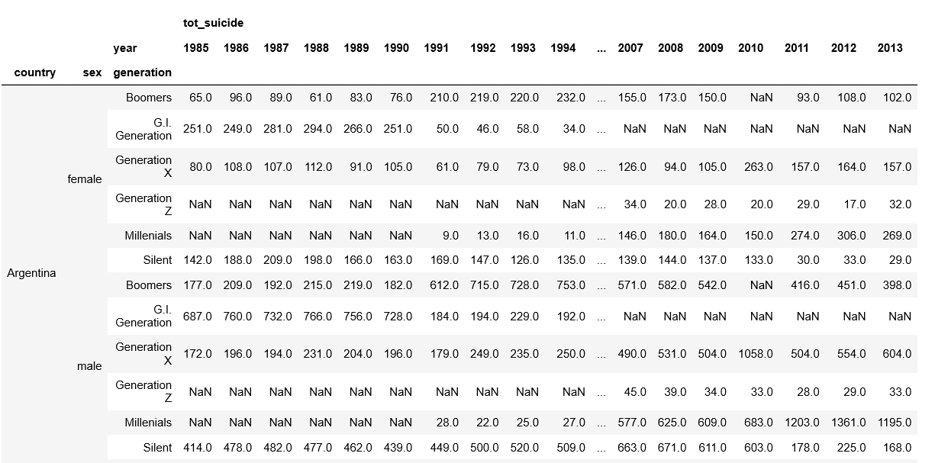

We then graphed out the information to reflect the movement of suicides by age and generation over the years.

Fig 5.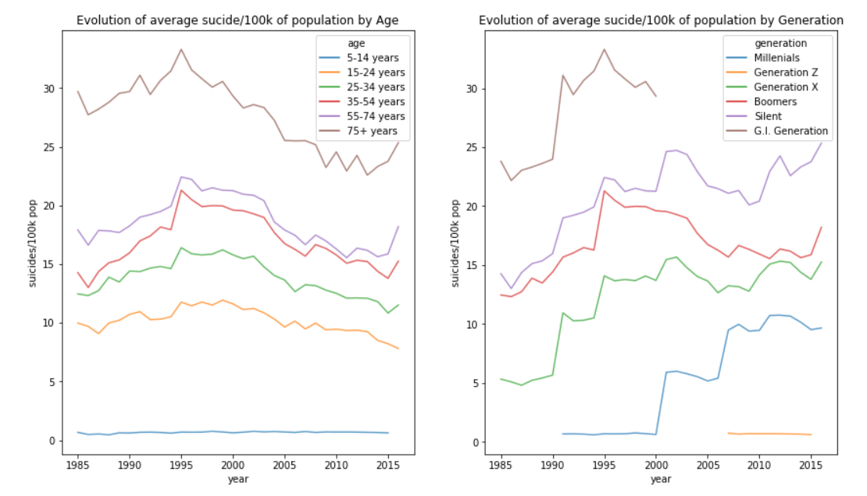

Figure 5. reflects the number of suicides were on the decline in the early 2000s however between 2010-2015 the numbers appear to be on the rise again. The following article confirms suicide rates are on the rise for various reason, mental illness is on the rise as well as poor economy. Later in the report we will be investigating if developing countries are more affected than those in developed countries.

<https://www.usnews.com/news/best-countries/articles/2019-02-07/global-suicide-rate-declines-while-us-rate-rises-study-finds>

Fig 6.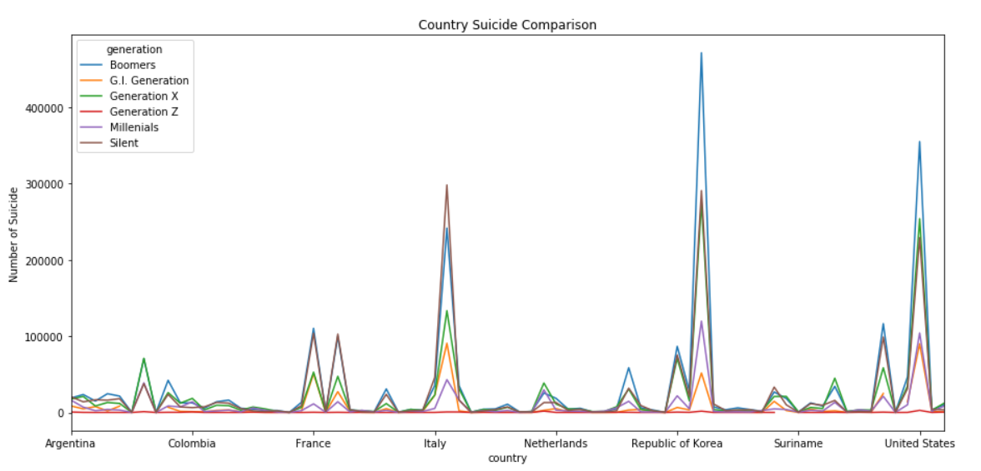

**Figure 6. Country Suicides comparison by Generation**

Figure 6 reflects that certain countries have higher rates of suicide by generation than others. One of the top 10 countries with high suicide numbers is Republic of Korea.

According to the WHO the suicide rate in South Korea is the 10th highest in the world. As reflected in the figures the highest generation for suicide is amongst the elderly. The reason provided for this is because aging parents do not want to feel like they are a financial burden on their families, in a culture where tradition is for the family to take care of their elderly parents. <https://worldpopulationreview.com/countries/suicide-rate-by-country/>

Based on age and generation, it is determined males have a higher number of suicides, most being from the Boomer generation. Further investigation into Global trends vs. Canada needs to be explored with a more investigative look at if developed vs. developing countries have any influence on the total number of suicides.